Phishing Email Analysis Report (by Mukesh Murugan)
Objective
To identify phishing characteristics present in a suspicious PayPal email sample.
Email Details
Subject: [PayPal]: Your account access has been limited
Sender: services@paypal-accounts.com
Claim: The recipient's PayPal account has been limited and must be verified within 24 hours.
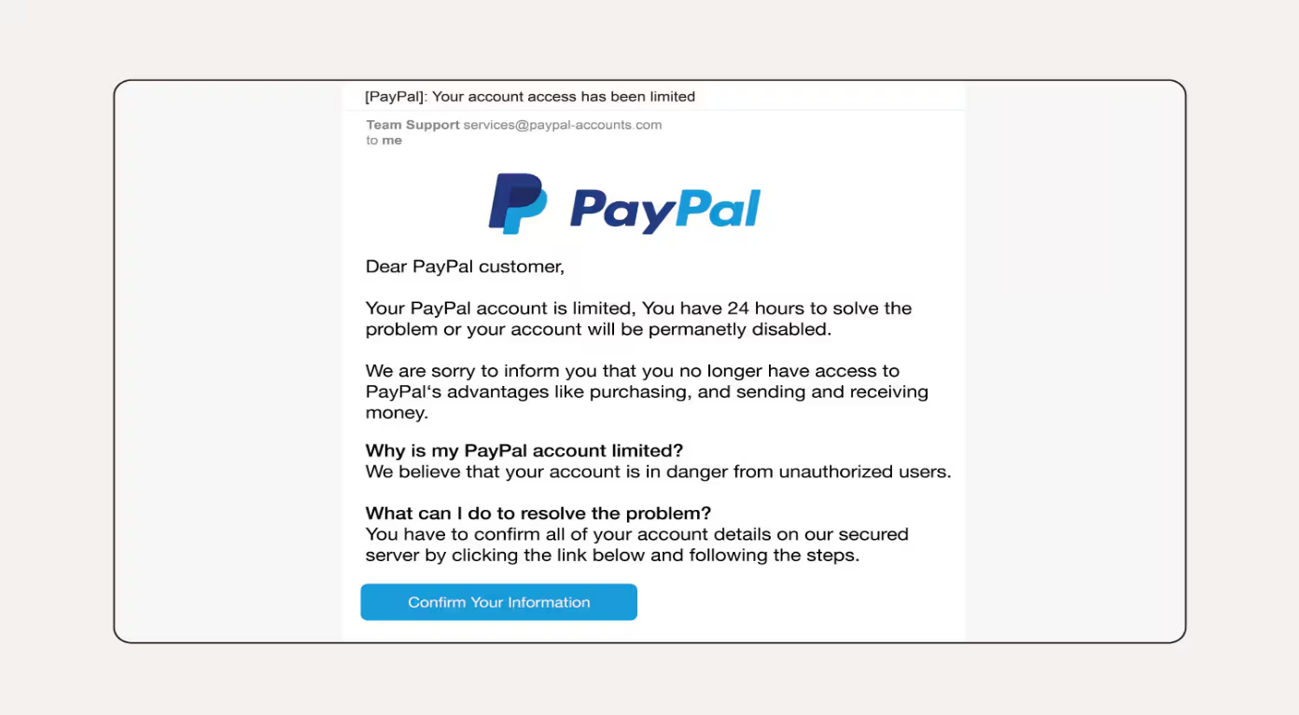
Phishing Indicators Identified
1. Suspicious Sender Address
The email originates from services@paypal-accounts.com rather than an official PayPal domain.
Legitimate PayPal emails are typically sent from domains ending in @paypal.com.
Indicator: Email Spoofing

2. Generic Greeting
The email begins with:
"Dear PayPal customer"
Legitimate companies usually address customers by their registered name.
Indicator: Generic Greeting

3. Creates Urgency
The email states:
"You have 24 hours to solve the problem or your account will be permanently disabled."
This creates pressure and encourages the victim to act without verifying the email.
Indicator: Urgent Language

4. Fear-Based Social Engineering
The email claims that the user's account is limited and may be disabled permanently.
Attackers commonly use fear to manipulate victims into clicking malicious links.
Indicator: Social Engineering Attack

5. Requests Sensitive Information
The email instructs the user to:
"Confirm all of your account details"
Legitimate organizations rarely request sensitive account information through email links.
Indicator: Credential Theft Attempt

6. Suspicious Action Button
The email contains a button labeled:
"Confirm Your Information"
Phishing emails often use buttons that redirect users to fake login pages designed to steal credentials.
Indicator: Suspicious Link/Button

7. Lack of Specific Account Information
The email does not mention:
- Customer name
- Account number
- Transaction details
Legitimate security notifications generally contain account-specific information.
Indicator: Lack of Personalization

Summary of Findings
Phishing Indicator | Status
Suspicious Sender Address | Found
Generic Greeting | Found
Urgent Language | Found
Fear Tactics | Found
Credential Harvesting Attempt | Found
Suspicious Button/Link | Found
Lack of Personalization | Found

Conclusion
The analyzed email exhibits multiple phishing characteristics, including email spoofing, urgency tactics, social engineering, and attempts to obtain sensitive account information. The email is highly suspicious and should be treated as a phishing attempt. Users should avoid clicking links, verify the sender's identity, and report such emails to their email provider or security team.
Recommended Actions
- Do not click the "Confirm Your Information" button.
- Verify account status directly through the official PayPal website.
- Report the email as phishing.
- Delete the email after reporting.
- Enable Multi-Factor Authentication (MFA) on important accounts.

